SIMATS ENGINEERING
ASSESSMENT TOOL 1

COURSE NAME: INTERNET PROGRAMMING
COURSE CODE: CSA4307

COURSE OUTCOME COVERED

CO 3: Implement dynamic web applications by utilizing DOM-based client-side scripting and employing Java Servlets for server-side request processing and response handling. (L3)

Assessment Tool : Scenario-Based Assessment

Weightage: 40%
Dr.V.Parthipan

QUESTIONS: Total Marks: 30

Question 1
Suppose that a college wants to develop an online student registration system where students submit their details through a web form, and the data is processed using a Java Servlet.
Explain the architecture of a servlet-based application. Design and implement a servlet to handle form data using both GET and POST methods. Describe the servlet life cycle (init, service, destroy) and justify which method is more appropriate for handling sensitive data.

1.1 Architecture of a Servlet-Based Application
A servlet-based application is a web application that uses Java Servlets to process requests from users and send responses back to the browser.
The main components are:
- Client (Browser): The student enters details using an HTML form.
- Web Server / Servlet Container: A server such as Apache Tomcat receives the request and manages the servlet.
- Java Servlet: The servlet processes the submitted student details.
- Database: Student information can be stored in MySQL.
- Response: The servlet sends a message or result back to the browser.
Client Browser
HTML Form + CSS + JavaScript
Apache Tomcat
Servlet Container
Java Servlet
Processes GET and POST requests
MySQL Database
Stores student details

1.2 HTML Form
Create a file named register.html.
HTML

<!DOCTYPE html>
<html>
<head>
<title>Student Registration</title>
<style>
body {
font-family: Arial;
margin: 30px;
background-color: #f2f2f2;
}

form {
background: white;
padding: 20px;
width: 300px;
border: 1px solid gray;
}

input, button {
width: 100%;
padding: 8px;
margin: 8px 0;
box-sizing: border-box;
}

button {
background-color: lightblue;
border: 1px solid gray;
cursor: pointer;
}
</style>
</head>
<body>

<h2>Student Registration Form</h2>

<form action="register" method="post"
onsubmit="return validateForm()">

<label>Name:</label>
<input type="text" id="name" name="name" required>

<label>Email:</label>
<input type="email" id="email" name="email" required>

<label>Department:</label>
<input type="text" id="department"
name="department" required>

<button type="submit">Register</button>
</form>

<script>
function validateForm() {
let name = document.getElementById("name").value.trim();
let email = document.getElementById("email").value.trim();

if (name === "" || email === "") {
alert("Please fill in all required fields");
return false;
}

alert("Submitting registration...");
return true;
}
</script>

</body>
</html>
Explanation:
- HTML creates the student registration form.
- CSS adds basic spacing, a background, and a button.
- JavaScript checks the form before submission.
- The form sends data to the servlet using the POST method.

1.3 Java Servlet Using GET and POST
Create StudentServlet.java.
Java

import java.io.IOException;
import java.io.PrintWriter;

import jakarta.servlet.ServletException;
import jakarta.servlet.annotation.WebServlet;
import jakarta.servlet.http.HttpServlet;
import jakarta.servlet.http.HttpServletRequest;
import jakarta.servlet.http.HttpServletResponse;

@WebServlet("/register")
public class StudentServlet extends HttpServlet {

@Override
public void init() throws ServletException {
System.out.println("Servlet initialized");
}

// Handles GET requests
@Override
protected void doGet(HttpServletRequest request,
HttpServletResponse response)
throws ServletException, IOException {

response.setContentType("text/html;charset=UTF-8");

PrintWriter out = response.getWriter();
out.println("<h2>Student Registration</h2>");
out.println("<p>Use the registration form to submit details.</p>");
}

// Handles POST requests
@Override
protected void doPost(HttpServletRequest request,
HttpServletResponse response)
throws ServletException, IOException {

request.setCharacterEncoding("UTF-8");
response.setContentType("text/html;charset=UTF-8");

String name = request.getParameter("name");
String email = request.getParameter("email");
String department = request.getParameter("department");

PrintWriter out = response.getWriter();

out.println("<h2>Registration Successful</h2>");
out.println("<p>Name: " + escape(name) + "</p>");
out.println("<p>Email: " + escape(email) + "</p>");
out.println("<p>Department: " + escape(department) + "</p>");
}

private String escape(String value) {
if (value == null) return "";
return value.replace("&", "&amp;")
.replace("<", "&lt;")
.replace(">", "&gt;")
.replace("\"", "&quot;")
.replace("'", "&#39;");
}

@Override
public void destroy() {
System.out.println("Servlet destroyed");
}
}
Note: This code uses jakarta.servlet, suitable for Tomcat 10 or later. For Tomcat 9, use the corresponding javax.servlet imports.
How the servlet works
- @WebServlet("/register") maps the servlet to the /register URL.
- doGet() handles GET requests, typically used for retrieving information.
- doPost() receives student details from the registration form.
- getParameter() reads form values.
- PrintWriter sends an HTML response to the browser.
- escape() helps prevent submitted text from being interpreted as HTML.

1.4 Servlet Life Cycle
The servlet life cycle consists of three main methods.
Method | Explanation
init() | Called once when the servlet is initialized.
service() | Handles incoming requests and dispatches them to methods such as doGet() and doPost().
destroy() | Called when the servlet is taken out of service.
The container generally initializes the servlet once, uses it to process multiple requests, and destroys it when it is being removed or the application is shutting down.

1.5 GET vs POST
GET | POST
Data is commonly sent in the URL. | Data is sent in the request body.
Suitable for retrieving information. | Suitable for submitting form data.
Parameters may appear in browser history and server logs. | Form parameters are not normally shown in the URL.
Limited practical suitability for large submissions. | Better suited for larger form submissions.
Not suitable for sensitive form data. | More appropriate for sensitive form data when used with HTTPS.
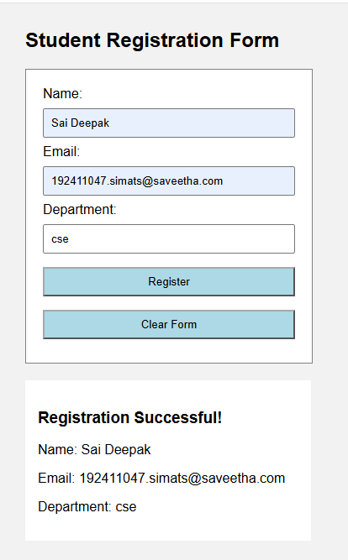

Conclusion: POST is more appropriate for student registration because the form submits personal details. However, POST alone does not provide security. HTTPS, server-side validation, and proper data protection are also necessary.

Question 2
Suppose that a website requires users to log in and maintain their session across multiple pages after authentication.
Design a session management system using HttpSession and Cookies in Servlets. Explain how session tracking works in web applications and compare session-based tracking with cookies.

2.1 Introduction
Session management is used to maintain a user's login status while moving from one page to another. HTTP is stateless, meaning that each request is independent by default.
For example, when a student logs in, the website should remember the student when they open the dashboard or another page.
Two common techniques are:
- HttpSession: Stores user information on the server.
- Cookies: Store small pieces of information in the user's browser.

2.2 Login Form with CSS

<!DOCTYPE html>
<html>
<head>
<title>Student Login</title>

<style>
body {
font-family: Arial;
background-color: #f2f2f2;
text-align: center;
padding: 40px;
}

.box {
background: white;
width: 300px;
margin: auto;
padding: 20px;
border: 1px solid gray;
border-radius: 8px;
}

input {
width: 90%;
padding: 10px;
margin: 8px;
}

button {
padding: 10px 20px;
background: blue;
color: white;
border: none;
cursor: pointer;
}

#dashboard {
display: none;
}
</style>
</head>

<body>

<div class="box" id="loginBox">
<h2>Student Login</h2>

<form onsubmit="return login()">
<input type="text" id="username"
placeholder="Enter Username" required>

<input type="password" id="password"
placeholder="Enter Password" required>

<br>
<button type="submit">Login</button>
</form>

<p id="message"></p>
<p>Demo username: student</p>
<p>Demo password: 1234</p>
</div>

<div class="box" id="dashboard">
<h2>Welcome!</h2>
<p id="welcomeMessage"></p>
<p>You have successfully logged in.</p>
<button onclick="logout()">Logout</button>
</div>

<script>
function login() {
var username =
document.getElementById("username").value;

var password =
document.getElementById("password").value;

if (username === "student" && password === "1234") {
sessionStorage.setItem("username", username);

document.getElementById("loginBox").style.display = "none";
document.getElementById("dashboard").style.display = "block";

document.getElementById("welcomeMessage").textContent =
"Hello, " + username;

} else {
document.getElementById("message").textContent =
"Invalid username or password!";
}

return false;
}

function logout() {
sessionStorage.removeItem("username");

document.getElementById("dashboard").style.display = "none";
document.getElementById("loginBox").style.display = "block";

document.getElementById("username").value = "";
document.getElementById("password").value = "";
document.getElementById("message").textContent =
"You have logged out.";
}

window.onload = function() {
var username = sessionStorage.getItem("username");

if (username) {
document.getElementById("loginBox").style.display = "none";
document.getElementById("dashboard").style.display = "block";
document.getElementById("welcomeMessage").textContent =
"Hello, " + username;
}
};
</script>

</body>
</html>

2.3Comparison Between HttpSession and Cookies
HttpSession | Cookies
Data is stored on the server. | Data is stored in the browser.
Can store objects and multiple values. | Stores small text values.
Commonly identified using JSESSIONID. | Sent with matching requests according to cookie settings.
Session can expire due to inactivity. | Cookie can expire at a specified time.
Suitable for login status and user information. | Suitable for preferences and session identifiers.
Requires server-side session storage. | Browser stores the cookie data.

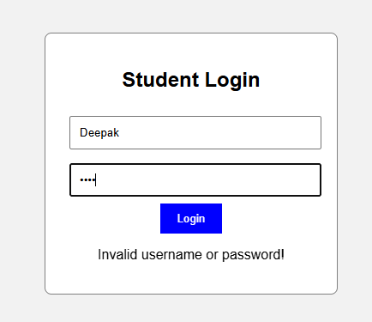
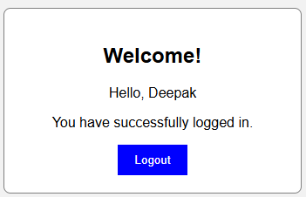
Conclusion: HttpSession is appropriate for maintaining login status and protecting pages. Cookies help identify sessions and remember preferences. Sensitive information such as passwords should never be stored in cookies.

Question 3
Suppose that an e-commerce platform needs to store and retrieve product details from a database using a Java-based web application.
Design a JDBC-based application to connect to a database, insert product data, and retrieve it using SQL queries. Explain the JDBC architecture and describe the steps involved in database connectivity along with proper exception handling.
3.1 Introduction
JDBC stands for Java Database Connectivity. It is a Java API used to connect Java applications with databases such as MySQL.
In an e-commerce application, JDBC can be used to insert product details, retrieve products, update information, and delete records.
The main components are:
- Java application or Servlet.
- JDBC API.
- JDBC driver.
- MySQL database.
- SQL queries for inserting and retrieving product details.

3.2 JDBC Architecture
Java Web Application
HTML Form + Java Servlet
JDBC API
Connection, PreparedStatement, ResultSet
MySQL JDBC Driver
Communicates with the database
MySQL Database
Stores product records

<!DOCTYPE html>
<html>
<head>
<title>Product Management</title>

<style>
body {
font-family: Arial;
background-color: #f2f2f2;
text-align: center;
padding: 30px;
}

.box {
background: white;
padding: 20px;
max-width: 600px;
margin: auto;
border: 1px solid gray;
border-radius: 8px;
}

input {
padding: 10px;
margin: 6px;
width: 80%;
}

button {
padding: 10px 15px;
background: green;
color: white;
border: none;
cursor: pointer;
}

table {
width: 100%;
margin-top: 20px;
border-collapse: collapse;
}

th, td {
border: 1px solid gray;
padding: 8px;
}

th {
background: lightgray;
}
</style>
</head>

<body>

<div class="box">
<h2>Product Management System</h2>

<form onsubmit="return addProduct()">
<input type="text" id="name"
placeholder="Product Name" required>

<input type="number" id="price"
placeholder="Product Price"
min="0.01" step="0.01" required>

<input type="number" id="quantity"
placeholder="Quantity"
min="0" step="1" required>

<br>
<button type="submit">Add Product</button>
</form>

<p id="message"></p>

<h3>Product Details</h3>

<table>
<thead>
<tr>
<th>ID</th>
<th>Name</th>
<th>Price</th>
<th>Quantity</th>
</tr>
</thead>

<tbody id="productTable"></tbody>
</table>

<br>
<button onclick="clearProducts()">Clear All Products</button>
</div>

<script>
var products = JSON.parse(
localStorage.getItem("products") || "[]"
);

function displayProducts() {
var table = document.getElementById("productTable");
table.textContent = "";

products.forEach(function(product) {
var row = document.createElement("tr");

[product.id, product.name, product.price,
product.quantity].forEach(function(value) {
var cell = document.createElement("td");
cell.textContent = value;
row.appendChild(cell);
});

table.appendChild(row);
});
}

function addProduct() {
var name = document.getElementById("name").value.trim();
var price = Number(document.getElementById("price").value);
var quantityText = document.getElementById("quantity").value;
var quantity = Number(quantityText);

if (name === "" || price <= 0 ||
quantityText === "" || quantity < 0 ||
!Number.isInteger(quantity)) {
document.getElementById("message").textContent =
"Please enter valid product details.";
return false;
}

var product = {
id: products.length ?
Math.max(...products.map(function(p) {
return p.id;
})) + 1 : 1,
name: name,
price: price.toFixed(2),
quantity: quantity
};

products.push(product);

localStorage.setItem("products", JSON.stringify(products));

displayProducts();

document.getElementById("message").textContent =
"Product added successfully!";

document.getElementById("name").value = "";
document.getElementById("price").value = "";
document.getElementById("quantity").value = "";

return false;
}

function clearProducts() {
products = [];
localStorage.removeItem("products");
displayProducts();

document.getElementById("message").textContent =
"All products cleared.";
}

displayProducts();
</script>

</body>
</html>

3.3 JDBC Connectivity Steps
The following are the main steps involved in JDBC connectivity.
Step | Description
1. Import packages | Import java.sql classes.
2. Load driver if required | Modern JDBC drivers are normally discovered automatically.
3. Establish connection | Use DriverManager.getConnection().
4. Create statement | Use PreparedStatement for SQL queries.
5. Execute query | Use executeUpdate() for INSERT, UPDATE and DELETE; use executeQuery() for SELECT.
6. Process results | Read the ResultSet returned by SELECT.
7. Handle exceptions | Catch SQLException and report errors safely.
8. Close resources | Use try-with-resources to close connections, statements and result sets.

3.4 Exception Handling in JDBC
Exception handling prevents database errors from crashing the application without a controlled response.
Common exceptions and problems include:
- SQLException: Connection failure or SQL query error.
- NumberFormatException: Invalid numeric input.
- Invalid database credentials: Incorrect username or password.
- Missing database or table: The required database objects do not exist.
The code uses try-catch and try-with-resources to handle errors and release database resources automatically. Database credentials should be stored in environment variables or secure configuration rather than hardcoded in a production application.

3.5 Advantages of JDBC
- Connects Java applications to relational databases.
- Supports SQL queries.
- Allows insertion, retrieval, updating and deletion of data.
- Supports parameterized queries through PreparedStatement, helping prevent SQL injection.
- Supports transaction management.
- Can be used in dynamic web applications.
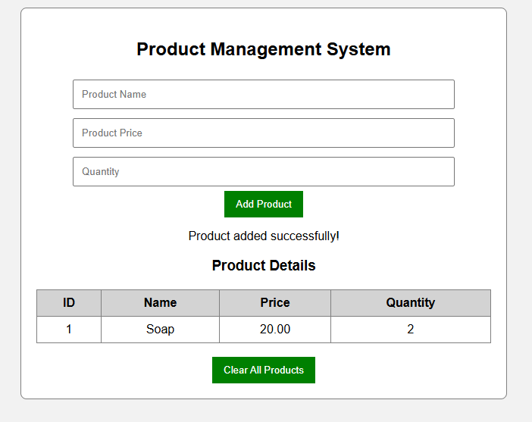
Conclusion: JDBC provides a connection between a Java web application and a database. In the product management scenario, the servlet accepts product details, uses JDBC to store them in MySQL, and retrieves the saved records for display.

Code of Conduct:

I PINDIBOINA SAI DEEPAK (192411047) certify that this submission is my original work and that I have adhered to the guidelines specified for this assessment.
I understand that any violation of academic integrity rules will result in disciplinary action.

Signature of the student: Sai Deepak

RUBRICS FOR CALCULATION:

Criteria | Weightage (%) | Level 4 (Exemplary) | Level 3 (Proficient) | Level 2 (Developing) | Level 1 (Beginning)
Understanding of Scenario | 20% | Demonstrates clear and complete understanding of the scenario and context | Shows good understanding with minor gaps | Partial understanding; misses key aspects | Misinterprets or fails to understand the scenario
Identification of Key Issues | 20% | Accurately identifies all relevant issues and factors involved | Identifies most key issues with minor omissions | Identifies limited issues; some irrelevant points | Unable to identify key issues
Application of Concepts | 25% | Applies appropriate concepts effectively to address the scenario | Applies concepts with minor errors | Limited or partially correct application | Unable to apply relevant concepts
Decision Making | 20% | Makes well-reasoned, logical decisions with strong rationale | Makes reasonable decisions with some justification | Makes weak decisions with limited justification | No clear decisions made or rationale provided
Clarity of Response | 15% | Response is clear, structured, and logically presented | Generally clear with minor issues | Somewhat unclear or poorly structured | Disorganized and difficult to understand

